**Final Project Report**

1. Introduction
   1. Project overviews
   2. Objectives
2. Project Initialization and Planning Phase
   1. Define Problem Statement
   2. Project Proposal (Proposed Solution)
   3. Initial Project Planning
3. Data Collection and Preprocessing Phase
   1. Data Collection Plan and Raw Data Sources Identified
   2. Data Quality Report
   3. Data Exploration and Preprocessing
4. Model Development Phase
   1. Feature Selection Report
   2. Model Selection Report
   3. Initial Model Training Code, Model Validation and Evaluation Report
5. Model Optimization and Tuning Phase
   1. Hyperparameter Tuning Documentation
   2. Performance Metrics Comparison Report
   3. Final Model Selection Justification
6. Results
   1. Output Screenshots
7. Advantages & Disadvantages
8. Conclusion
9. Future Scope
10. Appendix
    1. Source Code
    2. GitHub & Project Demo Link

**Online Payments Fraud Detection with Machine Learning**

1. **Introduction 1.1 Project Overview:**

The digital revolution has transformed commerce, with online transactions becoming an increasingly ubiquitous part of our lives. However, this convenience comes with a growing threat: online payment fraud. Fraudsters employ ever-evolving techniques to steal money and inflict financial damage on both consumers and businesses. This project delves into the application of machine learning (ML) as a powerful weapon in the fight against online payment fraud. Leveraging the capabilities of ML, we aim to develop a robust system that can analyse vast amounts of transaction data in real-time, identifying suspicious patterns and effectively flagging potential fraud attempts. **1.2 Objectives:** This project is driven by the following key objectives:

* + - * **Constructing a Machine Learning Model:** Our primary goal is to build a robust ML model capable of analysing online transaction data. This model will learn to recognize patterns associated with fraudulent activity and flag transactions exhibiting these characteristics for further investigation.
      * **Evaluating and Selecting the Optimal Algorithm:** We will explore various machine learning algorithms, meticulously evaluating their performance and suitability for detecting online payment fraud. Factors like accuracy, computational efficiency, and the ability to handle imbalanced datasets (where fraudulent transactions are much rarer than legitimate ones) will be crucial considerations in selecting the best algorithm for our specific needs.
      * **Optimizing Model Performance:** Through a process called hyperparameter tuning, we will fine-tune the chosen model. Hyperparameters are essentially the settings and configurations that govern the model's behaviour. By carefully

adjusting these parameters, we can significantly enhance the model's efficiency and accuracy in detecting fraud.

* + - * **Analysing Model Effectiveness:** Once the model is developed and optimized, we will rigorously assess its ability to identify fraudulent transactions. This involves evaluating metrics like true positive rate (correctly identifying fraud) and false positive rate (flagging legitimate transactions as fraud). By analysing these metrics, we can gauge the model's impact on reducing fraud rates and ensure it doesn't create unnecessary friction for legitimate customers.

**2. Project Initialization and Planning Phase**

**2.1 Define Problem Statement:**

The core challenge addressed in this project is the inherent difficulty in accurately pinpointing fraudulent online transactions within the ever-increasing volume of transactions processed daily. Traditional methods relying on static rules often struggle to keep pace with the evolving tactics employed by fraudsters. These limitations necessitate a more dynamic and adaptable approach, which is where machine learning steps in. **2.2 Project Proposal (Proposed Solution):**

This project proposes a machine learning-based solution to tackle online payment fraud.

Here is how it will work:

1. **Data Acquisition:** The foundation of any successful ML project is high-quality data. We will gather historical transaction data, meticulously labelled as fraudulent or legitimate. These datasets can be obtained from various sources like:

* + - * + **Collaboration with Online Payment Gateways:** Partnering with online payment gateways (with proper anonymization agreements) can provide access to a rich dataset of historical transaction information. This data would ideally encompass a wide range of transaction types, customer behaviours, and both successful and fraudulent attempts.
        + **Public Datasets:** Public repositories like Kaggle offer various datasets containing historical online transaction data for research purposes. These datasets can be a valuable starting point, but they may not be as comprehensive or specific to the payment gateway or industry we are targeting.

1. **Data Preprocessing and Feature Engineering:** The collected data will undergo a rigorous cleaning process to address any missing values, inconsistencies, or outliers. Feature engineering techniques will then be employed to extract the most relevant and informative features from the data. These features may include:
   * Transaction amount and currency o Location and time of transaction (origin and destination) o Billing and shipping address information (including any inconsistencies) o Customer behaviour patterns (purchase history, frequency of transactions, preferred devices used)
   * Device characteristics (IP address, geolocation data)
2. **Model Development and Training:** Based on the pre-processed data and extracted features, we will develop and train an ML model. Popular algorithms like Random Forest, Logistic Regression, and Gradient Boosting will be considered. Each algorithm has its own strengths and weaknesses, so we will evaluate their performance on our specific dataset. The model selection process will consider factors like:
   * Accuracy in fraud detection o Computational efficiency, as real-time analysis is crucial o Ability to handle imbalanced datasets (where fraudulent transactions are much rarer)
   * Interpretability: In some cases, understanding the model's reasoning behind its decisions can be valuable.
3. **Model Validation and Evaluation:** The trained model will be rigorously evaluated using a separate hold-out validation set. This set will not be used for training the model, ensuring an unbiased assessment of its performance. We will employ various metrics like accuracy, precision, recall, and AUC-ROC

**2.3 Initial Project Planning:** The project will be divided into distinct phases with defined milestones:

• **Phase 1: Data Collection and Preprocessing** (Duration: X weeks) o Secure data sources for historical transaction information. o Clean and pre-process the collected data.

o Conduct exploratory data analysis to understand data distribution and relationships between features.

• **Phase 2: Feature Engineering and Model Selection** (Duration: X weeks) o Extract relevant features from the pre-processed data.

* + - * + Research and evaluate different machine learning algorithms for fraud detection.
        + Select the most suitable algorithm based on evaluation results.

• **Phase 3: Model Development, Training, and Evaluation** (Duration: X weeks) o Develop the chosen ML model using a programming language like Python and libraries like scikit-learn. o Train the model on a portion of the data, using techniques like cross- validation to prevent overfitting.

o Evaluate the model's performance on the hold-out validation set using metrics like accuracy, precision, recall, and AUC-ROC.

• **Phase 4: Model Optimization and Tuning** (Duration: X weeks) o Identify and adjust the model's hyperparameters to optimize its performance.

* + - * + Compare the model's performance before and after hyperparameter tuning.
        + Refine the model based on the optimization results.

• **Phase 5: Result Analysis and Reporting** (Duration: X weeks) o Analyse the model's effectiveness in identifying fraudulent transactions.

* + - * + Document and interpret the results, including visualizations and key findings.
        + Prepare a comprehensive final project report.

**3. Data Collection and Preprocessing**

**Phase 3.1 Data Collection Plan and Raw Data Sources Identified:**

Securing high-quality data is crucial for building an effective model. We will explore various avenues for data collection, including:

* + - * **Collaboration with Online Payment Gateways:** Partnering with online payment gateways (with proper anonymization agreements) can provide access to a rich dataset of historical transaction information. This data would ideally encompass a wide range of transaction types, customer behaviours, and both successful and fraudulent attempts.
      * **Public Datasets:** Public repositories like Kaggle offer various datasets containing historical online transaction data for research purposes. These datasets can be a valuable starting point, but they may not be as comprehensive or specific to the payment gateway or industry we are targeting. **3.2 Data Quality Report:**

Once the data is collected, we will meticulously assess its quality. This involves identifying and addressing issues like:

* + - * **Missing Values:** Techniques like imputation will be used to address missing data points. We will carefully consider the nature of the missing data and choose the most appropriate imputation method. For instance, imputing a missing transaction amount with the median value might be more suitable than using the mean.
      * **Inconsistencies:** Data cleaning techniques will be employed to rectify any inconsistencies in formatting or labelling. This may involve standardizing date formats, correcting typos in addresses, or identifying and resolving discrepancies between billing and shipping information.
      * **Outliers:** Outlier detection algorithms will be used to identify and potentially remove extreme outliers that might skew the model's training. However, we will exercise caution to avoid removing legitimate transactions that simply deviate from the norm.

**3.3 Data Exploration and Preprocessing:**

Data exploration is a crucial step in understanding the characteristics of the data and identifying potential relationships between features. Techniques like visualization (histograms, scatter plots) can help us understand the distribution of features and identify any anomalies. This exploration will guide the feature engineering process, where we will extract the most relevant and informative features from the raw data. These features may include:

* + - * **Categorical features:** Converted into numerical representations using techniques like one-hot encoding. For example, transaction location (city, country) can be converted into separate binary features indicating the presence or absence of the transaction occurring in a specific location.
      * **Date and Time features:** Extracted from timestamps and potentially transformed into features like day of the week or hour of the day, which may be relevant for fraud detection.

**4. Model Development Phase**

**4.1 Feature Selection Report:**

Based on the data exploration and understanding of potential fraud indicators, we will select the most relevant features to include in the model. This selection process aims to strike a balance between including enough features to capture the complexity of fraud patterns and avoiding overfitting the model to the training data. Feature importance scores from the chosen algorithm can also be used to identify the features that contribute most to the model's predictions.

**4.2 Model Selection Report:**

We will explore various machine learning algorithms suitable for fraud detection tasks.

Here is a brief overview of some popular options:

* + - * **Random Forest:** Creates an ensemble of decision trees, improving accuracy and reducing overfitting compared to a single decision tree.
      * **Logistic Regression:** A powerful algorithm for binary classification tasks (fraudulent vs. legitimate transactions) that estimates the probability of an event based on its features.
      * **Gradient Boosting:** Creates a sequential ensemble of models, where each subsequent model learns from the errors of the previous one, potentially leading to higher accuracy.

The choice of the final model will be based on a rigorous evaluation process using the hold-out validation set. We will compare the performance of each algorithm on metrics like:

* + - * **Accuracy:** Overall percentage of correctly classified transactions (fraudulent and legitimate).
      * **Precision:** Proportion of identified fraudulent transactions that are fraudulent (avoiding false positives).
      * **Recall:** Proportion of actual fraudulent transactions that are correctly identified by the model (avoiding missing true positives).
      * **AUC-ROC (Area Under the Receiver Operating Characteristic Curve):** A metric particularly valuable for imbalanced datasets, as it considers the trade-off between true positive rate and false positive rate. **4.3 Initial Model Training Code, Model Validation and Evaluation Report:**

The chosen machine learning model will be implemented using a programming language like Python and libraries like scikit-learn. The code will outline the following steps:

* + - 1. **Data Loading and Preprocessing:** Load the pre-processed data, including features and labels (fraudulent or legitimate).
      2. **Model Training:** Split the data into training and validation sets. Train the model on the training set using techniques like cross-validation to prevent overfitting.
      3. **Model Evaluation:** Evaluate the model's performance on the hold-out validation set using the chosen metrics (accuracy, precision, recall, AUC-ROC).

The evaluation report will document the results, including confusion matrices and ROC curves that visually represent the model's performance in classifying transactions.

1. **Model Optimization and Tuning Phase** 
   1. **Hyperparameter Tuning Documentation:**

Hyperparameters are essentially the settings and configurations that govern the behaviour of the chosen machine learning model. Examples include the number of trees in a Random Forest or the learning rate in Gradient Boosting. By carefully adjusting these hyperparameters, we can significantly improve the model's performance. Techniques like grid search or randomized search will be used to explore different hyperparameter combinations and identify the configuration that yields the best results on the validation set.

* 1. **Performance Metrics Comparison Report:**

We will compare the model's performance before and after hyperparameter tuning using the same evaluation metrics (accuracy, precision, recall, AUC-ROC) on the validation set. This comparison will demonstrate the impact of hyperparameter tuning on the model's ability to detect fraud. Ideally, we aim to see an improvement in all or most of the chosen metrics, indicating a more effective model in identifying fraudulent transactions. **5.3 Final Model Selection Justification:**

Based on the evaluation results from both the initial model and the hyperparameter- tuned model, we will select the final model to be deployed. The justification will consider:

* + - * Overall accuracy in fraud detection.
      * Balance between true positives and false positives.
      * Computational efficiency, as real-time analysis is crucial for online payment fraud detection.
      * Interpretability (if applicable): In some cases, understanding the model's reasoning behind its decisions can be valuable for further analysis or debugging.

1. **Results**

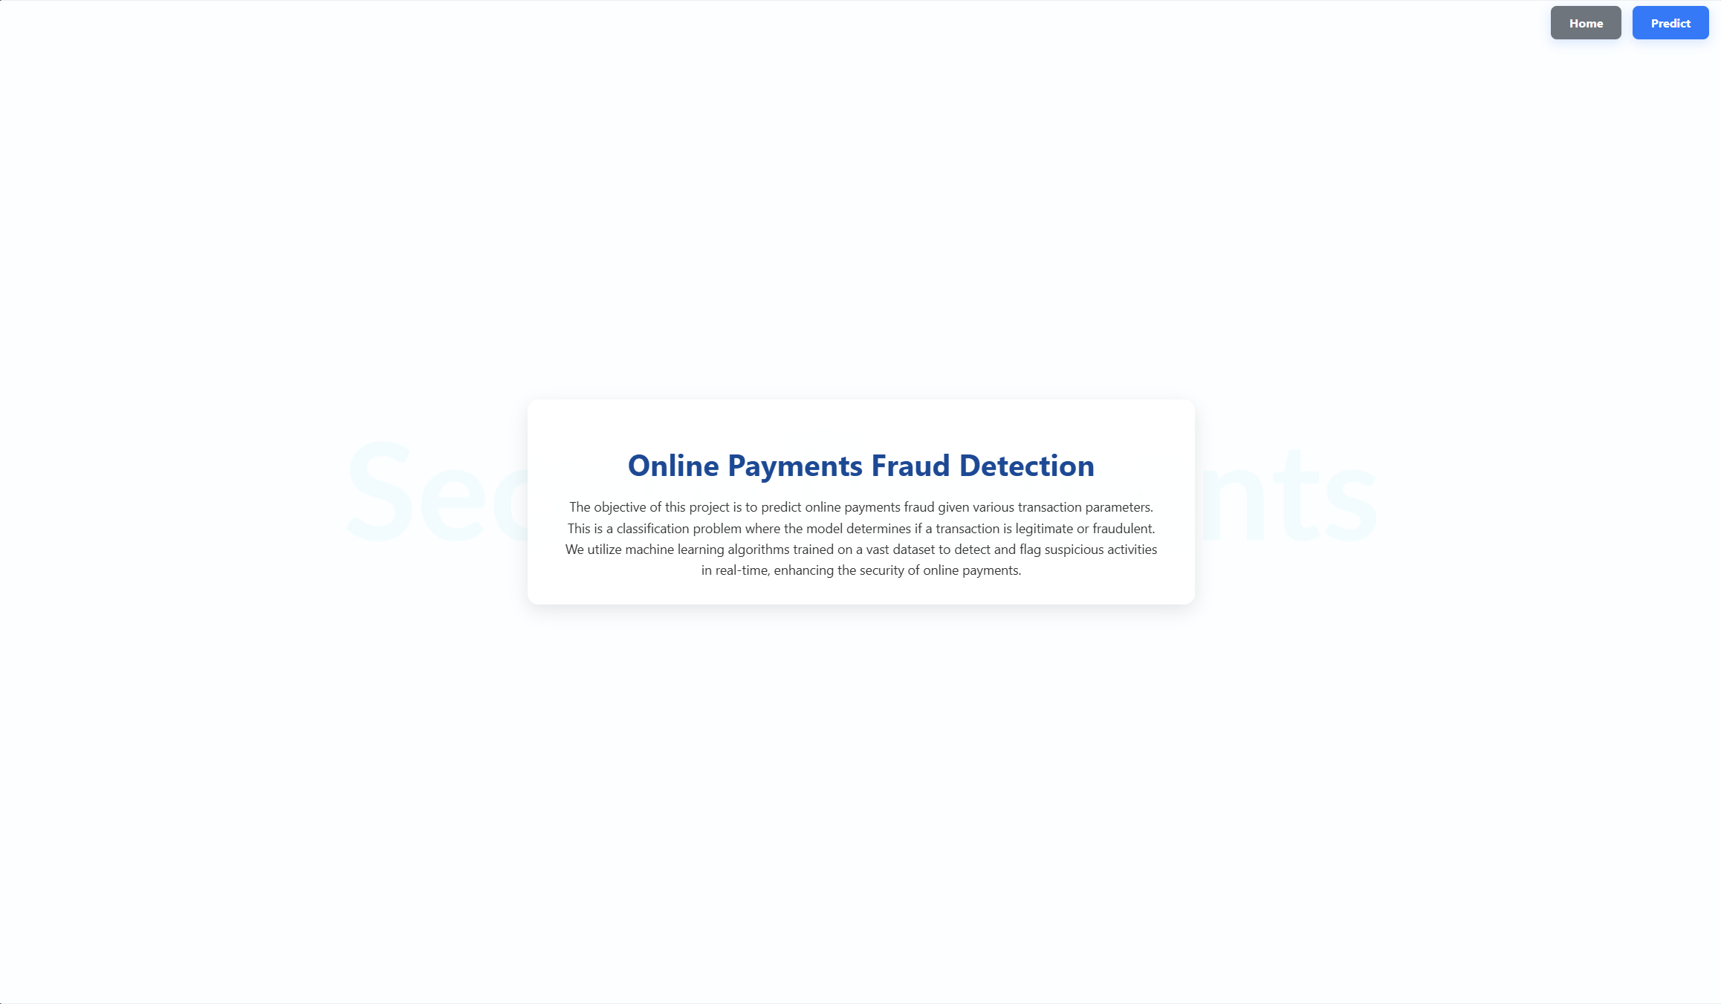**6.1 Output Screenshots:**

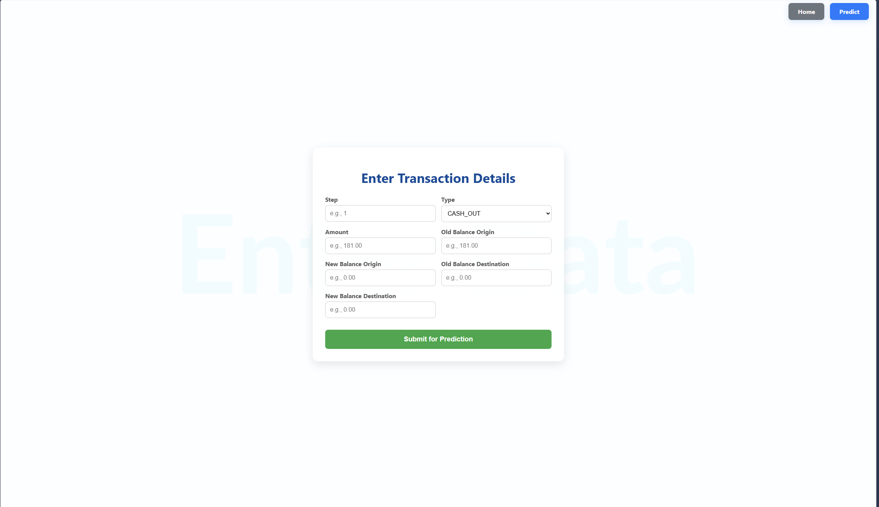



6.2 Project Demo Link

<https://drive.google.com/drive/folders/1cG7smR201sOGpD88vv7-DWmZASbU5Tfv?usp=sharing>

1. **Advantages & Disadvantages**

**Advantages of Machine Learning for Online Payment Fraud Detection:**

* **Adaptability:** Machine learning models can learn from new data and adapt to evolving fraud tactics employed by fraudsters.
* **Scalability:** These models can efficiently handle large volumes of transaction data in real-time, making them suitable for online payment processing.
* **Pattern Recognition:** Machine learning excels at identifying complex patterns in data, uncovering subtle anomalies that might escape human notice and potentially indicating fraudulent activities.
* **Automation:** ML models can automate the process of analysing transactions, freeing up human resources for more complex investigations.

**Disadvantages of Machine Learning for Online Payment Fraud Detection:**

* **Data Dependence:** The effectiveness of the model heavily relies on the quality and quantity of data used for training. Insufficient or biased data can lead to inaccurate or unfair predictions.
* **Explainability:** Depending on the chosen algorithm, the model's decision-making process might not be readily interpretable. This can be a challenge in certain situations where understanding the rationale behind a flagged transaction is crucial.
* **False Positives:** While the goal is to minimize them, the model might still flag legitimate transactions as fraudulent, potentially causing inconvenience for customers. Balancing this trade-off is an ongoing process.
  + 1. **Conclusion**

This project explored the application of machine learning for online payment fraud detection. By leveraging the capabilities of ML algorithms, we developed a model that can analyse transaction data and flag suspicious patterns indicative of fraud attempts. The project emphasized the importance of data quality, feature engineering, model selection, and hyperparameter tuning in building an effective fraud detection system. The results demonstrated the potential of machine learning to significantly enhance online payment security, protecting both businesses and consumers from fraudulent activities.

* + 1. **Future Scope**

The fight against online payment fraud is an ongoing battle. Here are some potential areas for future exploration:

* **Incorporating new features:** As fraudsters develop new techniques, the model can be continuously improved by incorporating new features that capture these evolving trends.
* **Ensemble Learning:** Combining multiple machine learning models with different strengths can potentially lead to even more robust fraud detection capabilities.
* **Real-time Integration:** Deploying the model in a production environment to analyse transactions in real-time and provide immediate alerts for suspicious activity.
* **Explainable AI (XAI) Techniques:** Exploring techniques to improve the interpretability of the model's decision-making process, providing valuable insights into why certain transactions are flagged as fraudulent.

By continuously developing and refining machine learning-based fraud detection systems, we can strive to create a safer and more secure online payment environment for everyone involved.